Isabella’s Final Exam Practice Problems (w/ answers!)

This document does not include: strong induction, inverse functions, composite functions, Cartesian product, countability of sets (sorry- made this document today so it’s does not 100% cover the course)

[Good luck](https://media.makeameme.org/created/thank-you-for-8803e0f619.jpg) tomorrow you guys you got this!!! Don’t stress out too much and make sure to eat a good breakfast and get sleep. If you have any questions, you can email them to [isabella.pham@rutgers.edu](mailto:isabella.pham@rutgers.edu) and I’ll get back to you ASAP (though I’m currently grinding comp arch so it may take a bit).

# Propositional Logic

Let p, q and r be the propositions:

p = ”You reside in NJ.”

q = ”You earn more than $10,000.”

r = ”You qualify for deduction 99L”

Write a propositional logic statement equivalent to:

1. “If you earn more than $10,000 and you do not reside in NJ, then you qualify for deduction 99L.”

2. “Residents of NJ qualify for deduction 99L only if they do not earn more than $10,000.”

3. Give a truth table for (p ∧ r) → ¬(q ∨ p)

# Predicates & Quantifiers

Let G(x, y) mean “Student x receives grade y in CS 205.”

Translate these sentences 1 and 2 into first-order logic:

1. Every student will receive a grade in CS 205.

2. Some student will not receive a grade in CS 205.

3. For each statement, say if it is true or false for Z (set of integers):

1. ∀x∃y x > y
2. ∃x∀y x > y
3. ∃x∃y x > y
4. ∀x∀y x > y

4. Which of these statements means ”f is onto/surjective”?

1. ∃y ∀x f (x) = y
2. ∀y ∃x f (x) = y
3. ∀x ∃y f (x) = y

5. Which of these statements means ”f is one-one/injective”?

1. ∀x ∀y (x =/= y) ∧ f (x) =/= f (y)
2. ∀x ∃y (x =/= y) ∧ f (x) =/= f (y)
3. ∀x ∀y (x =/= y) → f (x) =/= f (y)

6. Rewrite this expression so that no negation appears in front of a quantifier:

¬∃x ∀y ∀z ∃w Q(x, y, z, w)

7. Which of these implications are logically valid?

a) ∀x∃yP(x, y) → ∃y∀xP(x, y)

b) ∃y∀xP(x, y) → ∀x∃yP(x, y)

Your answer should be of the form, “only a”, “only b”, “a and b”, or “neither a nor b” (include an explanation).

# Sets

Let A be the set of all restaurants in NJ.

Let B be the set of all businesses in Piscataway, NJ.

Let C be the set of all businesses that advertise in the Targum.

Use set operations applied to A, B, and C to express these sets:

1. The set of restaurants in Piscataway that do not advertise in the

Targum.

2. The set of all businesses in Piscataway that are not restaurants, which

advertise in the Targum.

3. Let A be a set. Give a set B such that B ∈ P(A) and B ⊂ P(A) (where ⊂ indicates proper subset in this case- which means B is not equal to P(A)).

4. For each i ∈ N, let A i = {i · n : n ∈ N}. Say whether the following are true or false:

a) A1 = N

b) 0 ∈ A5

c) 1 ∈ A5

d) A15 ⊆ A1

5. Let A = {b, b, a} (which is a multiset, which means it allows repeat elements), and let B = {a, b, {a}}.

a) What is A − B?

b) What is A ∩ B?

c) Is A ⊆ B?

d) Is A ∈ B?

e) What is the cardinality of B?

f) What is the cardinality of A?

g) Is B − A ∈ A?

h) Is B − A ⊆ A?

# Induction

1. Let f be the function with the following recursive definition:

f (0) = 0

f (1) = 1

for all n ≥ 2, f (n) = f (n − 1) + 2f(n − 2) + 1

Prove by induction:

∀n ≥ 1, f (n) ≥ 2n−1

# Answers

## Propositional Logic

1. (q ∧ ¬p) → r

2. (p ∧ r) → ¬q

3. Plug the statement into this truth table generator: <https://web.stanford.edu/class/cs103/tools/truth-table-tool/>

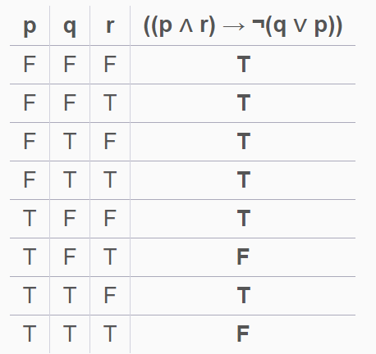

## Quantifiers

1. ∀x ∃y G(x,y)

2. ∃x ∀y not G(x,y)

3. T, F, T, F

4. b

5. C

6. ∀x ∃y ∃z ∀w ¬Q(x, y, z, w)

7. only b

## Sets

1. (A ⋂ B)-C

2. (B-A) ⋂ C

3. Choose B to be the empty set.

4. T, T, F, T

5.a Empty set

5.b {a,b}

5.c Yes

5.d No

5.e 3

5.f 2

5.g No

5.h No

## Induction

1. (sorry if it looks kinda ugly cause I typed it out)

Basis:

n=1: f(1) = 1 = 2^0 = 2^{n-1}

n=2: f(2) = f(1) + 2f(0) +1 = 1+0+1= 2 = 2^1 = 2^{n-1}

Induction step: Assume that f(n) is greater than or equal to 2^{n-1} and that f(n-1) is greater than or equal to 2^{n-2}. It will suffice to show that f(n+1) is greater than or equal to 2^n.

f(n+1) = f(n) + 2f(n-1)+1, which (by our inductive hypothesis) is greater than or equal to 2^{n-1} + 2*2^{n-2} + 1 = 2^{n-1}+2^{n-1}+1 = 2^n + 1 > 2^n.

QED